KV Cache
During inference, Mistral uses a KV cache to store key-value pairs and avoid redundant computation.
Question: BCS 8A
If each key-value (KV) pair requires 16 bytes of memory per token per layer, and Mistral 7B has 32 layers, how much memory (in MB) is required to store KV cache for a sequence of 2,048 tokens?
16 x 32 x 2048
Converting to bytes is not a compulsion...
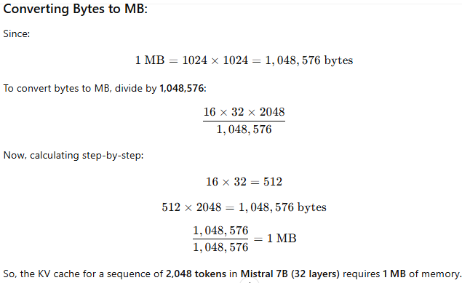

Sliding Window: BDS-8B
A sequence of 10,000 tokens is processed using Mistral's sliding window attention with a window size of 2,048 tokens. If each window overlaps with the next by 50%, how many overlapping attention windows are needed to cover the entire sequence?
• Total sequence length = 10,000 tokens
• Window size = 2,048 tokens
• Overlap = 50%
- This means each window overlaps by 1,024 tokens (since 50% of 2,048 = 1,024).
• Stride = 1,024 tokens (new window starts 1,024 tokens after the previous one).
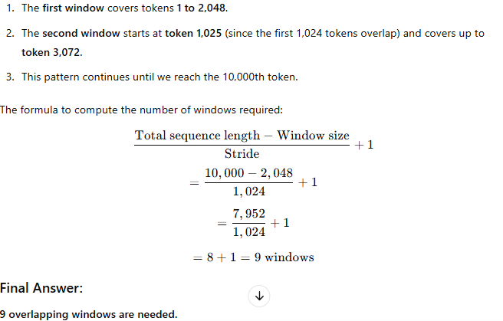

Pre-Fill & Chunking
Question: BDS 8A
If each chunk contains 2,048 tokens, how many chunks are required to process the entire 12,000-token sequence? What happens to the remaining tokens in the last chunk? Also mention the number of tokens in the last chunk.
